

ASSIGNMENT
How to Page
December 2013

Assignment Title: Air Attack

Student name : Luong Hong Ngoc, Trinh Luan
Student ID : S3425477, s3372775
Course : Mobile Application Developer
Lecturer : George Nguyen

accelerometer sensor

- INTRODUCTION:
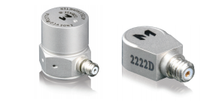
Beside environmental sensors and position sensors, Android devices have built-in the motion sensors in order to let application interact with the rotational forces and acceleration force. Accelerometer sensor is a hardware-base sensor that means it has some physical components built-in into the device. When players play the game, it can measure environmental property such as acceleration, geomagnetic field strength and angular change. In air attach, users can play the game in the new way base on this built-in. Accelerometer sensor will measures the acceleration force with all three physical axes (x, y and z) plus the force of gravity and navigate the airplane. In the other word, when players tilt the phone to the left, the airplane will move to the left and vice versa.

The developer should apply this new way of play in the arcade and action game to make player more interest to play. Especialy in racing and air attack game since users are so boring when touching to the soft navigation to control their character.

- ADVANTAGES:
- More fun when playing with new style
- Player can control with one hand. Even through their hand are dirty, players will not worry that they will make their phone screen dirty. For example, users can play the game when eating pizza

- DISADVANTAGES:
- Cannot control if users lying. Therefore, players will not sit on the chair and play the game for all night long.
- Some device are too old and there are do not have the physical components built-in to play this game.

- REQUIREMENTS:
- Android.hardware.sensor.accelerometer to uses motion readings from an accelerometer on the device
- LibGDX game engine to interact with the sensor
- The device which have accelerometer sensor built-in

- STEPS & SCREEN SHOTS:
We use getAccelerometerX() from Gdx library and getAccelerometerY() to know whenever users tilt the phone to the left or right and up or down. If this value of getAccelerometerX() less than 0 which means user tilt the phone to the right and if value of getAccelerometerY() less than 0 which means user tilt the phone to the forward and vice versa. Both X & Y values range from -10 to 10. When the value change, new position of the air plane will be updated and the code following will show how to update new position x and y of the airplane. This code will also update the image to make better interface; so user will feel thar the airplane are moving.
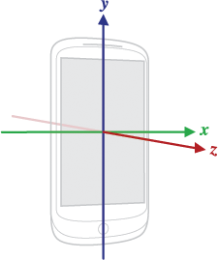

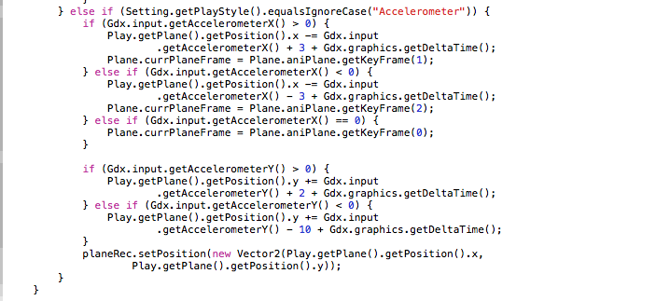
- REFERENCE:
https://www.endevco.com/news/newsletters/2012_07/tp327.pdf
http://developer.android.com/guide/topics/sensors/sensors_overview.html
https://code.google.com/p/libgdx/wiki/InputAccelerometer

